

Kingdom of Saudi Arabia
Ministry of Higher Education
King Faisal University
College of Computer Sciences & Information Technology

Library and Bookstore Management System
Database Concepts and Design Course Project
Year: 2025-26 Semester: II

Serial No | Name | ID | Sec
17 | Reda Alqatifi | 224032306 | 01
11 | Abdullah Alkhathlan | 224010043 | 01
11 | Ali Alburahim | 224001508 | 05
17 | Ali Alkhars | 224020801 | 05

Instructor: Muhammad Aasim Rafique

Table of Contents
Table of Contents 2
1. Introduction (case description) 3
2. System Analysis 4
A. List of users 4
B. List of main functions (at least three) 4
C. List of main reports (at least three) 4
3. Database Conceptual Design (ERD) 5
4. Logical Design (Relational Schema) 6
5. Physical Design 6
6. Populate Database 6
7. Queries 6
8. Application Development 7

Introduction (case description)
To effectively manage and optimize its operations, the Library requires a robust system that consolidates and tracks crucial information about its employees, customers, departments, and Books. This centralized system serves as the backbone for ensuring that the Library operates smoothly, providing accessible and accurate data that supports decision-making processes across all levels of the organization.
By maintaining detailed records of employee information, customer information, departmental structures, and all books —including those available in the system or ordered by customers—the system enables seamless coordination and communication. It also facilitates efficient human resource management, workforce planning, and improved book management.
Therefore, a well-structured solution is pivotal for the Library ability to adapt and respond to dynamic business needs, ultimately driving productivity and fostering informed strategic planning.

System Analysis

2.1 Requirement Specification
- The Library is organized into departments. Each department has a unique name, a unique ID, and a particular employee who manages the department.
- Each Book in the system has a unique code, a unique name, a price, a stock. Also, every book must contain at least one category and it must be written by at least one author. Books can be borrowed or purchased, and they must be recorded.
  - Borrowed books must be related to the order of the customer who borrowed it, and it must have a return date.
  - Purchased books must be related to the order of the customer who purchased it.
- The author has a unique ID, a nick-name, and a unique email to contact with him. Every author can write one or more books.
- All categories have a unique ID and a unique name. Also, one category can be contained by more than one book.
- Every user has a unique ID, a name, a unique email, a gender, and a hashed password. Also, each user may have a birth date. There are 2 types of users, which are:
  - The customer has an address and he can order one book or more–borrow and purchase–Each order has a unique number, order date, and a total price. Also, any customer can be served by one employee or more.
  - The employee has a unique key-code giving by his department manager, a salary, and working hours. Also, each employee must work for a department and this department must be managed by only one employee. Also, any employee can serve one customer or more. But only the manager can manage books. Also, every customer may be dependent of dependents.
    - Each dependent has a unique name, gender, and the relationship between him and the employee.

A. List of users
- Employee (including Manager role).
- Customer.

B. List of main functions (at least three)
1. Store and maintain detailed employee profiles, which include personal information, contact details, and work information such as salary and work hours.
2. Organize and categorize employees into various departments, enabling easy tracking of departmental structure.
3. Manage Books by the manager such as adding, deleting, updating, and ensuring clear oversight of purchased and borrowed books.
4. Generate detailed reports on various aspects, such as department details, orders details, and customer data, Load on employee.
5. Implement role-based access controls to ensure that sensitive information is accessible only to authorized personnel.
6. Manage customer orders (borrowing and purchasing), including recording return dates for borrowed books and tracking order history.
7. Store and maintain the list of dependents of employees for the family support claims or insurance claims

C. List of main reports (at least three)
1. Books with low or zero stock in the inventory.
2. Most borrowed/purchased books by category.
3. Number of authors who published their books in the library.
4. Number of customers and employees with their details.
5. Orders details, for whom and when.
6. Department details such as its employees and manager.

Database Conceptual Design (ERD)
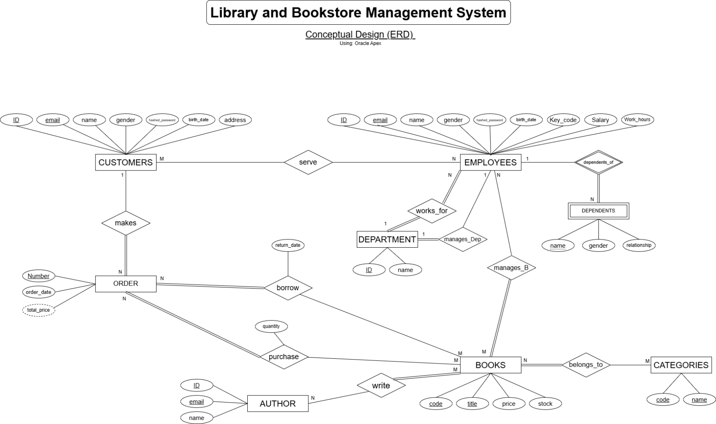

Logical Design (Relational Schema)

Physical Design

Table | code
Table | code
Table | code
Table | code
Table | code
Table | code
Table | code
Table | Code
Table | Code
Table | Code
Table | Code
Table | Code
Table | code
Table | code

Populate Database
Populate each table of your database with enough data (records) to answers certain queries.

Queries
You should run a number of test queries to see that you have loaded your database in the way you intended. Run at least five test queries to show interesting results.
e.g.
Generate a list of students in section 61 who took the database with Dr. Shaheen.
SELECT St_name
FROM STUDENT, SECTION, COURSE, INSTRUCTOR
WHERE Sec_no = 61 AND C_Name= “Database” AND I_Name =” Dr. Shaheen”

Application Development
Develop the application which will be used by users to access data and perform the certain business operation. The application should have the following minimum interfaces:
Application Guidelines
- ERD – No entity types are isolated, all connected
- ERD Mapping to Tables – All tables are correctly mapped from ERD
- All tables correctly implemented (at least 1 table for each student) - it will include Add, Edit, delete and searching.
- Relationship between tables working.
- proper addition of constraints at least – PK and FK
- Proper Data is inserted in the database
- Every table should have main FORM where we can perform the following tasks:
  - Add new data to tables using forms. Apply validation on each field (e.g. if Primary key is duplicate It should display an error message)
  - Delete/ update record from each table
  - If a record which refers to another table is deleted or updated; apply CASCADE Update and Cascade Delete (Primary foreign key relationship)
  - Navigation between records (e.g. MoveFirst, MoveLast, Next, Previous etc..)
- Implement each business functions for different users listed under sect 2-B
- Implement all reports which you have listed under 2-C, where the user should able to select few parameters and the system should provide a result summary.
You should provide screenshots of the application in your report with a proper description of each functionality in the order it has been performed. Each figure should be labeled and cited in the text.

- General Guidelines

Report Guidelines
- Create Table Queries written and shown in report
- Show screenshots of proper addition of constraints at least – PK and FK in report
- Proper Forms shown for input on report
- Screenshots shown with data on report
- Report Comprehension and Accuracy (Table of Contents, Introduction, Description of ERD, Description of Tables, Figures captions, tables captions are there and introduced in text)

Presentation Guidelines

- Give project demo with good presentation skills.
- If any group have changed the titles of the tables in the application. The application is properly configured and demonstrated with good titles.

Tasks to do:

No | Task | Student | Dou date | Status
T1 | Problem Statement | Reda | 31th March | ✅
T2 | SRS | Reda | 31th March | ✅
T3 | Conceptual Design (ERD) | Reda | 12th April | ✅
T4 | Logical Model | Alburahim | 1th May
T5 | Population of Data | Alburahim | 10th May
T6 | SQL Queries for Retrial of data for report (Complexity like using joins etc. ) | Alburahim
T7 | Forms | Abdullah
T8 | Reports | Alkhars
T9 | Physical Design (code) | Alkhars (6 tables)
 |  | Abdullah (6 tables)
 |  | Alburahim (1 table)
 |  | Reda (1 table)

